**AWS Final Project**

1. Create an S3 bucket with a unique name and upload the CSV file to the S3 bucket (ensure that the file is in UTF-8 format only)

* Open AWS S3 and follow the screen shots.

1. Create a crawler to crawl the CSV data and generate a metadata catalog

* Open Aws Glue and follow the screen shots.



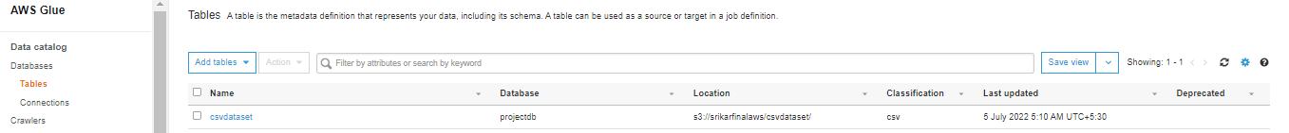

1. Create a Glue job to transform the data into the Parquet format as CSV is not optimal for data warehouse queries

* Open IAM and create a Role.

* Open AWS Glue 🡪 jobs and follow the screen shots.

1. Add another crawler to crawl the Parquet data files to generate the metadata catalog of the Parquet file in order to query it with Athena

* Follow the 2nd answer to create metadata catalog.

* Now open Aws Athena and follow the screen shots.

1. Query the data to identify the best-selling item and countries where customers have bought the most-sold item using Athena

